Mediant Studies

Test of knowledge required for AMusTCL course
Your answers to these questions will show whether or not you are familiar with the theory topics which students taking the course need to understand. Please do not use any books or ask anyone to help you.

1. Under these notes write their letter names (e.g. D#)
….… ….… ….… …… ….… ….… ….… ……
2. Name a time signature in compound duple metre: …
3. Under each note, write how many beats it would last for in 12/8 time.
…… …… …...
4. Which of these notes would be accented strongly? Note number ……

5. Which of the notes above would be held for the shortest time? Numbers …………
6. Fill in the names of the keys which have these key signatures:

,,,, major … minor … major … minor
7. Write a jazz/rock/guitar chord symbol above this chord: ……..
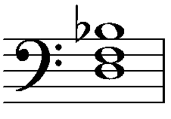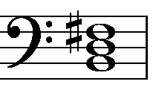
8. Write a figured bass below this chord:

..……
9. What is the fourth degree in the A flat major scale? ……..
10. If a clarinet in B flat plays G, which note will be heard? ………..
11. Which degree of the scale is the submediant? …….…..
12. What is the leading note in E harmonic minor? ……..
13. What is the interval between G and C#? ………………………..…..
14. Which cadence does not include chord V? ……………….…..
15. Which two cadences would not sound finished if used at the end of a piece? …………………………
16. Which instrument produces different notes when a slide is moved in or out? ………………………...
Continued on the next page.
17. Which stringed instrument in a standard orchestra is held between the knees? ………………………..
18. Which member of the woodwind family has music written in the bass or tenor clef? ………………....
19. What is the Italian name of the drums used to produce different pitches in an orchestra? ……………..
20. Name a pivot chord that could be used to modulate from D major to F# minor: ………..……..……..
21. What is the name of the type of melodic development used in this melody? ………..……..…….
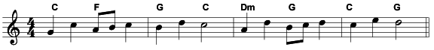22. What does SATB stand for? ………..……..……………..……..……………..……..……
23. In an orchestra score, are the parts for trumpets written above or below those of horns? ………..…
24. What is the meaning of the following:
pizzicato ………..……..……………..……..………………………………………..……..……..……
rubato ………..……..……………..……..………………………………………….…..…….…..……
iiº ……………..…………………………………………………………………………………….…
zu 2 ………………………………………………………………………………………………….…
a pedal note ………..……..……………..……..…………………………………………..……..……
tremolo ………..……..……………..……………………………………….……………..……..……
25. How does the mood of the music change in the passage below?
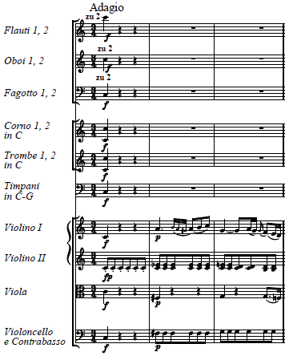
26. Name the key and chord at the end of bar 3 in the music above. ………………….……..……………
27. What is the name of the ornament played by first violins in bar 2 above? ………..……..……………
If you are not sure whether your answers are right, please email the form to bruce@mediantstudies.co.nz.

